**Dr.Babasaheb Ambedkar Marathwada**

**University, Aurangabad**

**pd. VASANTDADA PATIL COLLEGE OF COMPUTER**

**SCIENCE AND BCA, AURANGABAD**



**MAJOR PROJECT REPORT**

**On**

**"RESTAURANT MANAGEMENT**"

In partial fulfillment of Bachelor of Computer Science

Submitted by

**MR.NIRAJ AADE**

**MR.MAHESH B. JOSHI**

**MR.RAM CHAPHLE**

**BSC (computer science)- VI Semester**

**Guided by**

**DR.SONALI GUNJAL**

**Submitted to:**

**Dr. Babasaheb Ambedkar Marathwada University, Aurangabad**

**For the Academic Year 2021-22**

**Dr.Babasaheb Ambedkar Marathwada**

**University, Aurangabad**

**pd. VASANTDADA PATIL COLLEGE OF COMPUTER**

**SCIENCE AND BCA, AURANGABAD**



**CERTIFICATE**

**This is to certify that *Mr.* MR.NIRAJ AADE , MR.RAM CHAPHLE ,**

**MR.MAHESH B. JOSHI**

**of BCS VI- Semester, has successfully completed**

**his/her Major Project on the**

**"** **RESTAURANT MANAGEMENT ".**

**And has submitted a satisfactory report as per the requirement of**

**Dr. Babasaheb Ambedkar Marathwada University, Aurangabad in**

**partial fulfilment of bachler of computer science course.**

**For the academic year 2021-22.**

**DR.SONALI B. GUNJAL D.R. SONWANE**

**Project Guide HOD**

**Acknowledgement**

On the very outset of this report, I would like to extend my sincere & heartfelt obligation towards all the personages who have helped me in this endeavor. Without their active guidance, help, cooperation & encouragement, I would not have made headway in the project.

I am grateful to my project **Guide (DR. SONALI B. GUNJAL)** for the guidance, inspiration and constructive suggestions that helped me in the preparation of this project.

I express my thanks to the principle **Dr. D.R.Sonwane** for extending

his support.

I also acknowledge with a deep sense of reverence, my gratitude towards my parents and member of my family, who has always supported me morally as well as economically. At last but not least gratitude goes to all of my friends who directly or indirectly helped me to complete this project report. Any omission in this brief acknowledgement does not mean lack of gratitude.

|  |  |
| --- | --- |
| SR.No | NAME |
| 1 | Acknowledgement |
| 2 | Introduction |
| 3 | Features |
| 4 | Web diagram |
| 5 | Output program,  header section,footer section |
| 6 | Screen Layout,  A) home, B) About, C) menu  D) special dishes, E) Team  and F) Resrvation |
| 7 | Program  Html,CSS,Bootstrap |
| 8 | Conclution |

**INDEX**

**INTRODUCTION**

1. We are Introduce MARATHAS KITCHEN restaurant and our slogan is   
**STAY WITH US, FEEL AT HOME**.

2. In Home page we are showing tom our restaurant details and order food our restaurant.

3.In About Page we are showing to know our restaurant process and about quality of food

4. In Special dishesh page we are showing different dishesh they are loved many people.

5. In Menu Page will be shown as different breakfast , lunch and dinner recipes.

6. In Team Page we are telling you about the owner , CEO and chef of MARATHAS KITCHEN restaurant.

7. In reservation page we reserve the table in our restaurant and enjoy your life.

**For RESTAURANT WEBSITE Designing based on HTML and CSS**

Hypertext Markup language(HTML) is the standard markup language for creating webpages and web application.With Cascading style sheet(CSS)and java script,it forms a triad of cornerstone technologies for the world wide web. Web browser receive HTML document from a web server or from local storage and render them into multimedia web pages HTML describes the structure of web page semantically and originally and included cuesfor the appearance of the document.

HTML can embeded programs written in a scripting language such as java script which affect the behavior and contant of web pages. Inclusion of CSS defines athe look and layout of contant the world wide web Consortium(W3C), maintainer both the HTML and CSS standards, has encouraged the use of CSS over explicit presentational HTML since 1997.

**FEATURES:-**

**Features of MARATHAS KITCHEN RESTAURANT WEBSITE.**

1. Restaurant for new online portal for guest , tourist and all of the people.

2. This website is useful for knowing about the restaurant and its services.

3. In MARATHAS KITCHEN website we will be book a table and every services.

4. In this website we known about the what is special dishes and different food in this restaurant.

5. This MARATHAS KITCHEN website is very easy to use for everyone.

6. In this website we known about the menu of this restaurant and the opening time of the restaurant.

7. This process online portal.

**Brief overview of technology:**

Front end:HTML CSS,BOOTSTRAP

HTML:HTML is used to create and save web document.Eg. Notepad /Notepad++ CSS:(Cascading style sheet)Create a attractive layout.

**Why use HTML?**

HTML is use to create electronic documents(Called Pages)that are display on the world wide web.Each Page contains a series of conections to other pages called Hyperlink. Every you see on internet is written using one version of HTML code or another.

HTML code ensure thhe proper formatting of text and images so that your

internet browser may display them they are intended to look. Without HTML a

browserwould not know how to display test as a element or load images or

other elements.HTML also provides a basic structure of the page upon which

cascading style sheet are overlaid to change its appers.

**Existing System**

The work is done manually

Student will visit the web page and fill their two type Forms.

Example. Form 1" For the student will be filling for Living certificates

And benefited Certificate

Form 2 for the new student admissions will be apply Ex. 10" Passed

student will be apply and UG courses for the same application

But You select you want take take which class Admission

Like 11" select streme (arts science mcvc) same for the UG Courses

Admin will collect all student Admissions data database.

Printing Process will take Place,

**DIAGRAM**

Reservation

Menu

About

HOME

Team

Special Dishes

**OUTPUT PROGRAM**

**HOME PAGE**

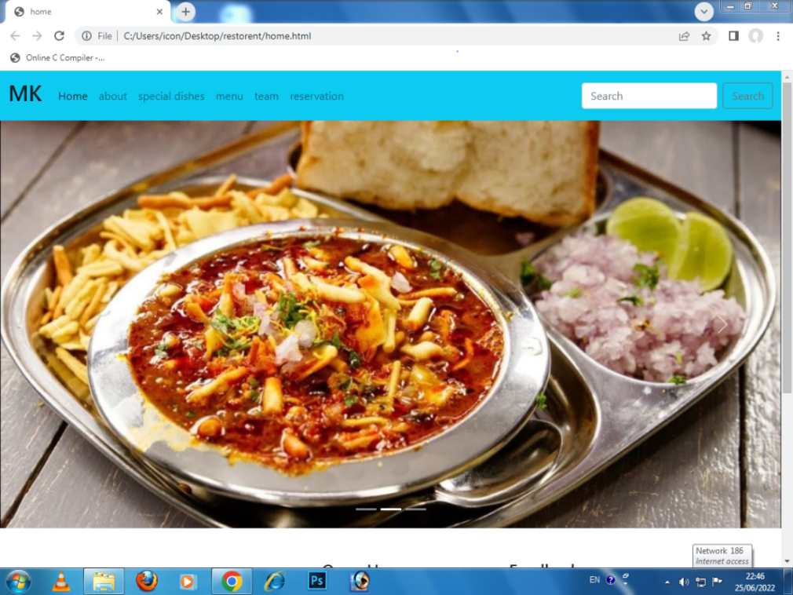

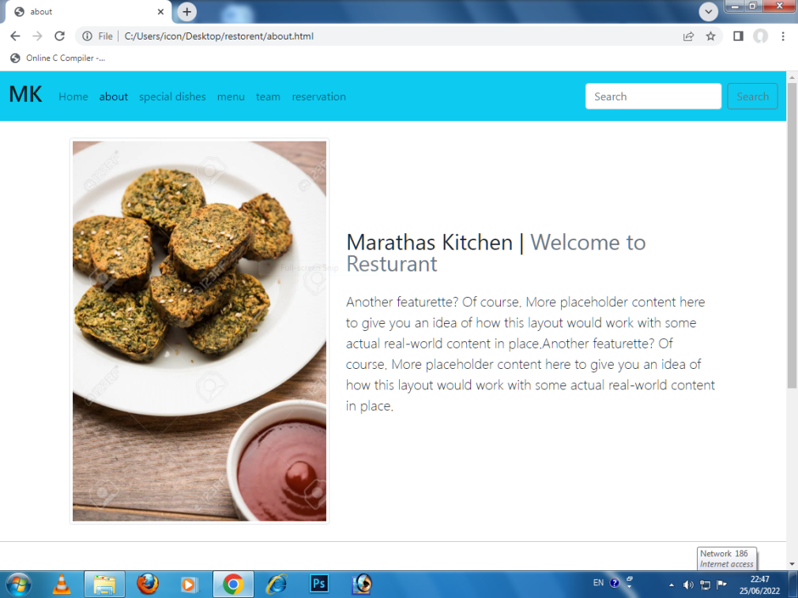ABOUT PAGE

SPECIAL DISHES

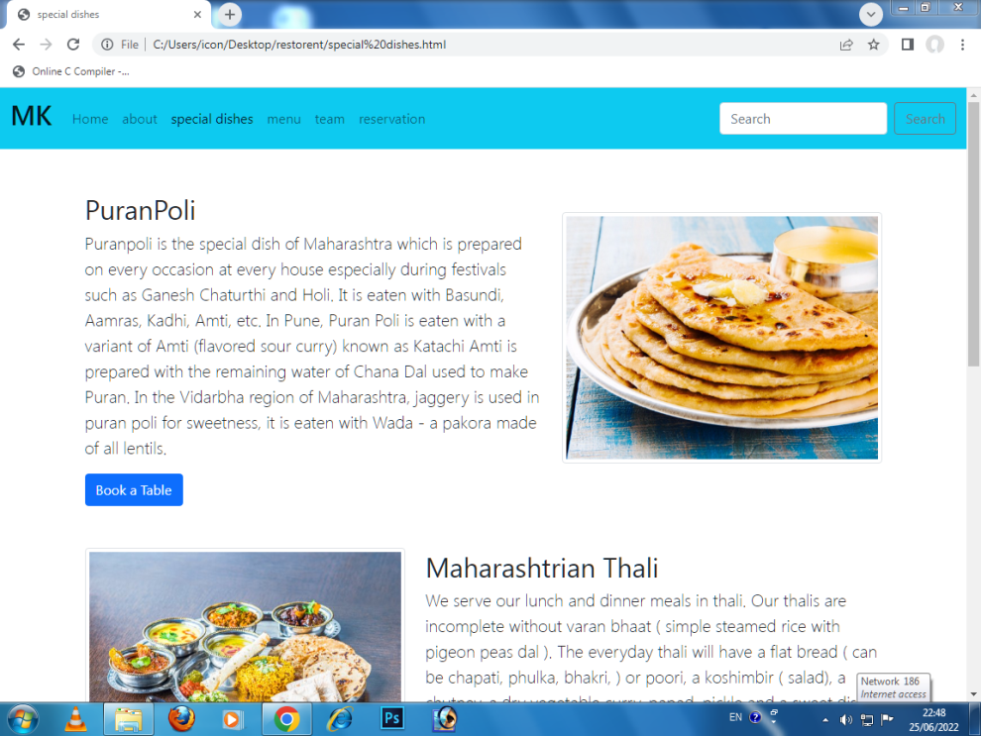

MENU PAGE

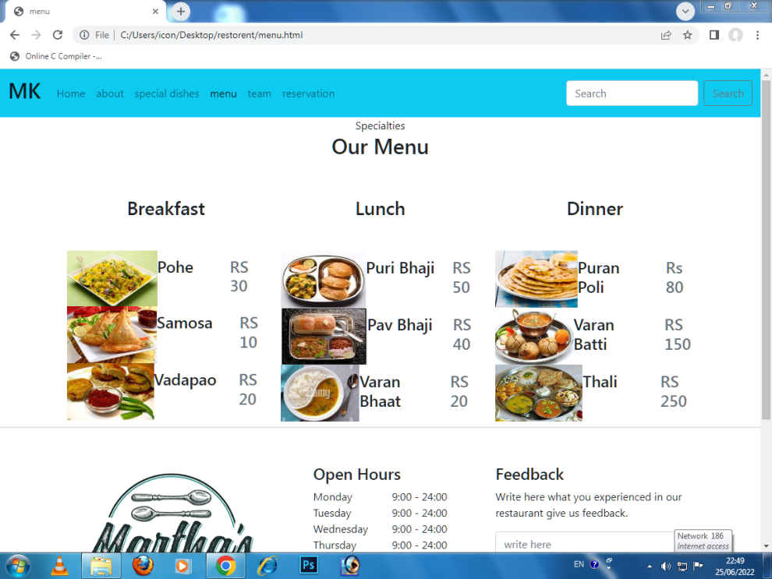

TEAM PAGE

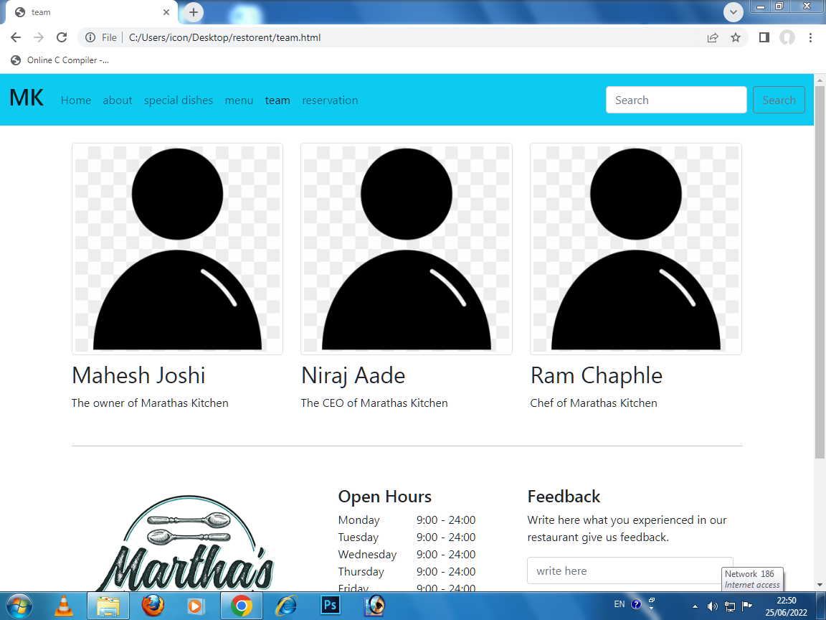

RESERVATION PAGE

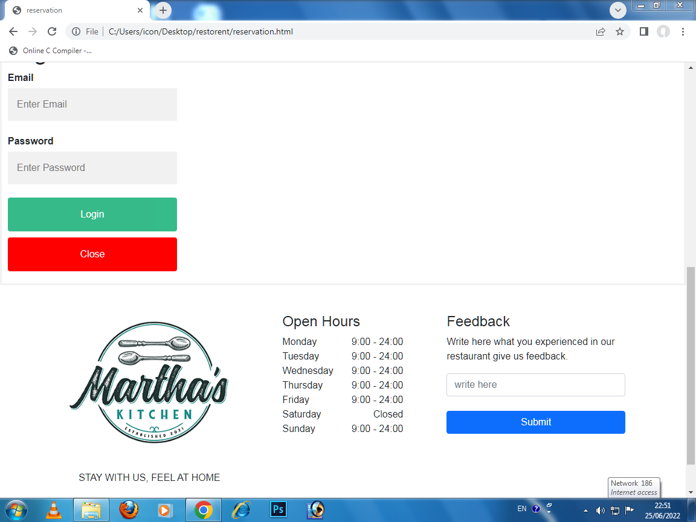

**SRC code**

**\*HTML , CSS AND BOOTSTRAP LINKS\***

**HOME PAGE**

<!doctype html>

<html lang="en">

<head>

<meta charset="utf-8">

<meta name="viewport" content="width=device-width, initial-scale=1">

<link href="https://cdn.jsdelivr.net/npm/bootstrap@5.1.3/dist/css/bootstrap.min.css" rel="stylesheet"

integrity="sha384-1BmE4kWBq78iYhFldvKuhfTAU6auU8tT94WrHftjDbrCEXSU1oBoqyl2QvZ6jIW3" crossorigin="anonymous">

<title>home</title>

<style>

* {

margin: 0px;

padding: 0px;

}

</style>

</head>

<body>

<nav class="navbar navbar-expand-lg navbar-light bg-info ">

<div class="container-fluid">

<a class="navbar-brand" href="#">

<h2>MK</h2>

</a>

<button class="navbar-toggler" type="button" data-bs-toggle="collapse" data-bs-target="#navbarSupportedContent"

aria-controls="navbarSupportedContent" aria-expanded="false" aria-label="Toggle navigation">

<span class="navbar-toggler-icon"></span>

</button>

<div class="collapse navbar-collapse" id="navbarSupportedContent">

<ul class="navbar-nav me-auto mb-2 mb-lg-0 ">

<li class="nav-item">

<a class="nav-link active" aria-current="page" href="home.html">Home</a>

</li>

<li class="nav-item">

<a class="nav-link" href="about.html">about</a>

</li>

<li class="nav-item">

<a class="nav-link" href="special dishes.html">special dishes</a>

</li>

<li class="nav-item">

<a class="nav-link" href="menu.html">menu</a>

</li>

<li class="nav-item">

<a class="nav-link" href="team.html">team</a>

</li>

<li class="nav-item">

<a class="nav-link" href="reservation.html">reservation</a>

</li>

</ul>

<form class="d-flex">

<input class="form-control me-2" type="search" placeholder="Search" aria-label="Search">

<button class="btn btn-outline-secondary" type="submit">Search</button>

</form>

</div>

</div>

</nav>

<div id="carouselExampleCaptions" class="carousel slide " data-bs-ride="carousel">

<div class="carousel-indicators">

<button type="button" data-bs-target="#carouselExampleCaptions" data-bs-slide-to="0" class="active"

aria-current="true" aria-label="Slide 1"></button>

<button type="button" data-bs-target="#carouselExampleCaptions" data-bs-slide-to="1"

aria-label="Slide 2"></button>

<button type="button" data-bs-target="#carouselExampleCaptions" data-bs-slide-to="2"

aria-label="Slide 3"></button>

</div>

<div class="carousel-inner">

<div class="carousel-item active">

<img src="a.jpg" class="d-block w-100" alt="...">

<div class="carousel-caption d-none d-md-block">

<h1></h1>

<p></p>

</div>

</div>

<div class="carousel-item">

<img src="b.jpg" class="d-block w-100" alt="...">

<div class="carousel-caption d-none d-md-block">

<h5></h5>

<p></p>

</div>

</div>

<div class="carousel-item">

<img src="c.jpg" class="d-block w-100" alt="...">

<div class="carousel-caption d-none d-md-block">

<h5></h5>

<p></p>

</div>

</div>

</div>

<button class="carousel-control-prev" type="button" data-bs-target="#carouselExampleCaptions" data-bs-slide="prev">

<span class="carousel-control-prev-icon" aria-hidden="true"></span>

<span class="visually-hidden">Previous</span>

</button>

<button class="carousel-control-next" type="button" data-bs-target="#carouselExampleCaptions" data-bs-slide="next">

<span class="carousel-control-next-icon" aria-hidden="true"></span>

<span class="visually-hidden">Next</span>

</button>

</div>

<p style="width:100%;height:30px;"></p>

<!-- End of menu Section --> <footer class="mastfoot pb-5 bg-white section-padding pb-0">

<div class="inner container">

<div class="row">

<div class="col-lg-4">

<div class="footer-widget pr-lg-5 pr-0">

<img src="hotellogo.png" class="img-fluid footer-logo mb-3" alt="">

<p><center>STAY WITH US, FEEL AT HOME</center></p>

<nav class="nav nav-mastfoot justify-content-start">

<a class="nav-link" href="#">

<i class="fab fa-facebook-f"></i>

</a>

<a class="nav-link" href="#">

<i class="fab fa-twitter"></i>

</a>

<a class="nav-link" href="#">

<i class="fab fa-instagram"></i>

</a>

</nav>

</div>

</div>

<div class="col-lg-4">

<div class="footer-widget px-lg-5 px-0">

<h4>Open Hours</h4>

<ul class="list-unstyled open-hours">

<li class="d-flex justify-content-between"><span>Monday</span><span>9:00 - 24:00</span></li>

<li class="d-flex justify-content-between"><span>Tuesday</span><span>9:00 - 24:00</span></li>

<li class="d-flex justify-content-between"><span>Wednesday</span><span>9:00 - 24:00</span></li>

<li class="d-flex justify-content-between"><span>Thursday</span><span>9:00 - 24:00</span></li>

<li class="d-flex justify-content-between"><span>Friday</span><span>9:00 - 24:00</span></li>

<li class="d-flex justify-content-between"><span>Saturday</span><span>Closed</span></li>

<li class="d-flex justify-content-between"><span>Sunday</span><span> 9:00 - 24:00</span></li>

</ul>

</div>

</div>

<div class="col-lg-4">

<div class="footer-widget pl-lg-5 pl-0">

<h4>Feedback</h4>

<p>Write here what you experienced in our restaurant give us feedback.</p>

<form id="newsletter">

<div class="form-group">

<input type="text" class="form-control" id="emailNewsletter" aria-describedby="emailNewsletter" placeholder="write here">

</div><br>

<button type="submit" class="btn btn-primary w-100">Submit</button>

</form>

</div>

</div>

<div class="col-md-12 d-flex align-items-center">

<p class="mx-auto text-center mb-0">Copyright 2019. All Right Reserved. Design by <a href="https://gettemplates.co" target="_blank">GetTemplates</a></p>

</div>

</div>

</div>

</footer> </div>

</div>

<script src="https://cdn.jsdelivr.net/npm/bootstrap@5.1.3/dist/js/bootstrap.bundle.min.js"

integrity="sha384-ka7Sk0Gln4gmtz2MlQnikT1wXgYsOg+OMhuP+IlRH9sENBO0LRn5q+8nbTov4+1p"

crossorigin="anonymous"></script>

<script src="https://cdn.jsdelivr.net/npm/@popperjs/core@2.10.2/dist/umd/popper.min.js"

integrity="sha384-7+zCNj/IqJ95wo16oMtfsKbZ9ccEh31eOz1HGyDuCQ6wgnyJNSYdrPa03rtR1zdB"

crossorigin="anonymous"></script>

<script src="https://cdn.jsdelivr.net/npm/bootstrap@5.1.3/dist/js/bootstrap.min.js"

integrity="sha384-QJHtvGhmr9XOIpI6YVutG+2QOK9T+ZnN4kzFN1RtK3zEFEIsxhlmWl5/YESvpZ13"

crossorigin="anonymous"></script>

</body>

</html>

**ABOUT PAGE**

<!doctype html>

<html lang="en">

<head>

<meta charset="utf-8">

<meta name="viewport" content="width=device-width, initial-scale=1">

<link href="https://cdn.jsdelivr.net/npm/bootstrap@5.1.3/dist/css/bootstrap.min.css" rel="stylesheet"

integrity="sha384-1BmE4kWBq78iYhFldvKuhfTAU6auU8tT94WrHftjDbrCEXSU1oBoqyl2QvZ6jIW3" crossorigin="anonymous">

<title>about</title>

<style>

* {

margin: 0px;

padding: 0px;

}

</style>

</head>

<body>

<nav class="navbar navbar-expand-lg navbar-light bg-info ">

<div class="container-fluid">

<a class="navbar-brand" href="#">

<h2>MK</h2>

</a>

<button class="navbar-toggler" type="button" data-bs-toggle="collapse"

data-bs-target="#navbarSupportedContent" aria-controls="navbarSupportedContent" aria-expanded="false"

aria-label="Toggle navigation">

<span class="navbar-toggler-icon"></span>

</button>

<div class="collapse navbar-collapse" id="navbarSupportedContent">

<ul class="navbar-nav me-auto mb-2 mb-lg-0 ">

<li class="nav-item">

<a class="nav-link " aria-current="page" href="home.html">Home</a>

</li>

<li class="nav-item">

<a class="nav-link active" href="about.html">about</a>

</li>

<li class="nav-item">

<a class="nav-link" href="special dishes.html">special dishes</a>

</li>

<li class="nav-item">

<a class="nav-link" href="menu.html">menu</a>

</li>

<li class="nav-item">

<a class="nav-link" href="team.html">team</a>

</li>

<li class="nav-item">

<a class="nav-link" href="reservation.html">reservation</a>

</li>

</ul>

<form class="d-flex">

<input class="form-control me-2" type="search" placeholder="Search" aria-label="Search">

<button class="btn btn-outline-secondary" type="submit">Search</button>

</form>

</div>

</div>

</nav>

<div class="container">

<div class="row featurette my-4" style="align-items: center;vertical-align: middle;">

<div class="col-md-5 order-md-1">

<img src="vadi.jpg" class="img-thumbnail" alt="...">

</div>

<div class="col-md-7 order-md-2">

<h2 class="featurette-heading fw-normal lh-1">Marathas Kitchen | <span class="text-muted">Welcome to Resturant</span></h2>

<p class="lead my-4">Another featurette? Of course. More placeholder content here to give you an idea of

how this layout would work with some actual real-world content in place.Another featurette? Of course. More placeholder content here to give you an idea of

how this layout would work with some actual real-world content in place.</p>

</div>

</div>

</div>

<hr class="dropdown-divider">

<p style="width:100%;height:30px;"></p>

<!-- End of menu Section --> <footer class="mastfoot pb-5 bg-white section-padding pb-0">

<div class="inner container">

<div class="row">

<div class="col-lg-4">

<div class="footer-widget pr-lg-5 pr-0">

<img src="hotellogo.png" class="img-fluid footer-logo mb-3" alt="">

<p><center>STAY WITH US, FEEL AT HOME</center></p>

<nav class="nav nav-mastfoot justify-content-start">

<a class="nav-link" href="#">

<i class="fab fa-facebook-f"></i>

</a>

<a class="nav-link" href="#">

<i class="fab fa-twitter"></i>

</a>

<a class="nav-link" href="#">

<i class="fab fa-instagram"></i>

</a>

</nav>

</div>

</div>

<div class="col-lg-4">

<div class="footer-widget px-lg-5 px-0">

<h4>Open Hours</h4>

<ul class="list-unstyled open-hours">

<li class="d-flex justify-content-between"><span>Monday</span><span>9:00 - 24:00</span></li>

<li class="d-flex justify-content-between"><span>Tuesday</span><span>9:00 - 24:00</span></li>

<li class="d-flex justify-content-between"><span>Wednesday</span><span>9:00 - 24:00</span></li>

<li class="d-flex justify-content-between"><span>Thursday</span><span>9:00 - 24:00</span></li>

<li class="d-flex justify-content-between"><span>Friday</span><span>9:00 - 24:00</span></li>

<li class="d-flex justify-content-between"><span>Saturday</span><span>Closed</span></li>

<li class="d-flex justify-content-between"><span>Sunday</span><span> 9:00 - 24:00</span></li>

</ul>

</div>

</div>

<div class="col-lg-4">

<div class="footer-widget pl-lg-5 pl-0">

<h4>Feedback</h4>

<p>Write here what you experienced in our restaurant give us feedback.</p>

<form id="newsletter">

<div class="form-group">

<input type="text" class="form-control" id="emailNewsletter" aria-describedby="emailNewsletter" placeholder="write here">

</div><br>

<button type="submit" class="btn btn-primary w-100">Submit</button>

</form>

</div>

</div>

<div class="col-md-12 d-flex align-items-center">

<p class="mx-auto text-center mb-0">Copyright 2019. All Right Reserved. Design by <a href="https://gettemplates.co" target="_blank">GetTemplates</a></p>

</div>

</div>

</div>

</footer> </div>

</div>

<script src="https://cdn.jsdelivr.net/npm/bootstrap@5.1.3/dist/js/bootstrap.bundle.min.js"

integrity="sha384-ka7Sk0Gln4gmtz2MlQnikT1wXgYsOg+OMhuP+IlRH9sENBO0LRn5q+8nbTov4+1p"

crossorigin="anonymous"></script>

<script src="https://cdn.jsdelivr.net/npm/@popperjs/core@2.10.2/dist/umd/popper.min.js"

integrity="sha384-7+zCNj/IqJ95wo16oMtfsKbZ9ccEh31eOz1HGyDuCQ6wgnyJNSYdrPa03rtR1zdB"

crossorigin="anonymous"></script>

<script src="https://cdn.jsdelivr.net/npm/bootstrap@5.1.3/dist/js/bootstrap.min.js"

integrity="sha384-QJHtvGhmr9XOIpI6YVutG+2QOK9T+ZnN4kzFN1RtK3zEFEIsxhlmWl5/YESvpZ13"

crossorigin="anonymous"></script>

</body>

</html>

**SPECIALDISHES**

<!doctype html>

<html lang="en">

<head>

<meta charset="utf-8">

<meta name="viewport" content="width=device-width, initial-scale=1">

<link href="https://cdn.jsdelivr.net/npm/bootstrap@5.1.3/dist/css/bootstrap.min.css" rel="stylesheet"

integrity="sha384-1BmE4kWBq78iYhFldvKuhfTAU6auU8tT94WrHftjDbrCEXSU1oBoqyl2QvZ6jIW3" crossorigin="anonymous">

<title>special dishes</title>

<style>

* {

margin: 0px;

padding: 0px;

}

</style>

</head>

<body>

<nav class="navbar navbar-expand-lg navbar-light bg-info ">

<div class="container-fluid">

<a class="navbar-brand" href="#">

<h2>MK</h2>

</a>

<button class="navbar-toggler" type="button" data-bs-toggle="collapse"

data-bs-target="#navbarSupportedContent" aria-controls="navbarSupportedContent" aria-expanded="false"

aria-label="Toggle navigation">

<span class="navbar-toggler-icon"></span>

</button>

<div class="collapse navbar-collapse" id="navbarSupportedContent">

<ul class="navbar-nav me-auto mb-2 mb-lg-0 ">

<li class="nav-item">

<a class="nav-link " aria-current="page" href="home.html">Home</a>

</li>

<li class="nav-item">

<a class="nav-link" href="about.html">about</a>

</li>

<li class="nav-item">

<a class="nav-link active" href="special dishes.html">special dishes</a>

</li>

<li class="nav-item">

<a class="nav-link" href="menu.html">menu</a>

</li>

<li class="nav-item">

<a class="nav-link" href="team.html">team</a>

</li>

<li class="nav-item">

<a class="nav-link" href="reservation.html">reservation</a>

</li>

</ul>

<form class="d-flex">

<input class="form-control me-2" type="search" placeholder="Search" aria-label="Search">

<button class="btn btn-outline-secondary" type="submit">Search</button>

</form>

</div>

</div>

</nav>

<div class="container">

<div class="row featurette my-4 " style="align-items: center;vertical-align: middle;">

<div class="col-md-7 ">

<h2 class="featurette-heading fw-normal lh-1 "><br>PuranPoli<span class="text-muted"></span></h2>

<p class="lead">Puranpoli is the special dish of Maharashtra which is prepared on every occasion at every house especially during festivals such as Ganesh Chaturthi and Holi. It is eaten with Basundi, Aamras, Kadhi, Amti, etc. In Pune, Puran Poli is eaten with a variant of Amti (flavored sour curry) known as Katachi Amti is prepared with the remaining water of Chana Dal used to make Puran. In the Vidarbha region of Maharashtra, jaggery is used in puran poli for sweetness, it is eaten with Wada - a pakora made of all lentils.</p>

<a href="#" class="btn btn-primary">Book a Table</a>

</div>

<div class="col-md-5">

<img src="puranpoli.jpg" class="img-thumbnail" alt="...">

</div>

</div>

<div class="row featurette my-4" style="align-items: center;vertical-align: middle;">

<div class="col-md-7 order-md-2">

<h2 class="featurette-heading fw-normal lh-1"><br>Maharashtrian Thali<span class="text-muted"></span></h2>

<p class="lead">We serve our lunch and dinner meals in thali. Our thalis are incomplete without varan bhaat ( simple steamed rice with pigeon peas dal ). The everyday thali will have a flat bread ( can be chapati, phulka, bhakri, ) or poori, a koshimbir ( salad), a chutney, a dry vegetable curry, papad, pickle and a sweet dish are made on all special occasions and festivals.</p>

<a href="#" class="btn btn-primary">Book a Table</a>

</div>

<div class="col-md-5 order-md-1">

<img src="thali.jpg" class="img-thumbnail" alt="...">

</div>

</div>

<div class="row featurette my-4" style="align-items: center;vertical-align: middle;">

<div class="col-md-7">

<h2 class="featurette-heading fw-normal lh-1" ><br>VaranBatti<span class="text-muted"></span></h2>

<p class="lead">Daal Batti is one such dish that was prepared mainly on such long journeys. It is very similar to the Daal-Baati of Rajasthan but still different.Dal bati is a traditional dish found in Rajasthan, Madhya Pradesh and parts of Maharashtra. Khandeshi Varan Batti is variant of the same in Khandesh region in Maharashtra.</p>

<a href="#" class="btn btn-primary">Book a Table</a>

</div>

<div class="col-md-5">

<img src="batti.jpg" class="img-thumbnail" alt="...">

</div>

</div>

</div>

<p style="width:100%;height:50px;"></p>

<!-- End of menu Section --> <footer class="mastfoot pb-5 bg-white section-padding pb-0">

<div class="inner container">

<div class="row">

<div class="col-lg-4">

<div class="footer-widget pr-lg-5 pr-0">

<img src="hotellogo.png" class="img-fluid footer-logo mb-3" alt="">

<p><center>STAY WITH US, FEEL AT HOME</center></p>

<nav class="nav nav-mastfoot justify-content-start">

<a class="nav-link" href="#">

<i class="fab fa-facebook-f"></i>

</a>

<a class="nav-link" href="#">

<i class="fab fa-twitter"></i>

</a>

<a class="nav-link" href="#">

<i class="fab fa-instagram"></i>

</a>

</nav>

</div>

</div>

<div class="col-lg-4">

<div class="footer-widget px-lg-5 px-0">

<h4>Open Hours</h4>

<ul class="list-unstyled open-hours">

<li class="d-flex justify-content-between"><span>Monday</span><span>9:00 - 24:00</span></li>

<li class="d-flex justify-content-between"><span>Tuesday</span><span>9:00 - 24:00</span></li>

<li class="d-flex justify-content-between"><span>Wednesday</span><span>9:00 - 24:00</span></li>

<li class="d-flex justify-content-between"><span>Thursday</span><span>9:00 - 24:00</span></li>

<li class="d-flex justify-content-between"><span>Friday</span><span>9:00 - 24:00</span></li>

<li class="d-flex justify-content-between"><span>Saturday</span><span>Closed</span></li>

<li class="d-flex justify-content-between"><span>Sunday</span><span> 9:00 - 24:00</span></li>

</ul>

</div>

</div>

<div class="col-lg-4">

<div class="footer-widget pl-lg-5 pl-0">

<h4>Feedback</h4>

<p>Write here what you experienced in our restaurant give us feedback.</p>

<form id="newsletter">

<div class="form-group">

<input type="text" class="form-control" id="emailNewsletter" aria-describedby="emailNewsletter" placeholder="write here">

</div><br>

<button type="submit" class="btn btn-primary w-100">Submit</button>

</form>

</div>

</div>

<div class="col-md-12 d-flex align-items-center">

<p class="mx-auto text-center mb-0">Copyright 2019. All Right Reserved. Design by <a href="https://gettemplates.co" target="_blank">GetTemplates</a></p>

</div>

</div>

</div>

</footer>

</div>

</div>

<script src="https://cdn.jsdelivr.net/npm/bootstrap@5.1.3/dist/js/bootstrap.bundle.min.js"

integrity="sha384-ka7Sk0Gln4gmtz2MlQnikT1wXgYsOg+OMhuP+IlRH9sENBO0LRn5q+8nbTov4+1p"

crossorigin="anonymous"></script>

<script src="https://cdn.jsdelivr.net/npm/@popperjs/core@2.10.2/dist/umd/popper.min.js"

integrity="sha384-7+zCNj/IqJ95wo16oMtfsKbZ9ccEh31eOz1HGyDuCQ6wgnyJNSYdrPa03rtR1zdB"

crossorigin="anonymous"></script>

<script src="https://cdn.jsdelivr.net/npm/bootstrap@5.1.3/dist/js/bootstrap.min.js"

integrity="sha384-QJHtvGhmr9XOIpI6YVutG+2QOK9T+ZnN4kzFN1RtK3zEFEIsxhlmWl5/YESvpZ13"

crossorigin="anonymous"></script>

</body>

</html>

**MENU PAGE**

<!doctype html>

<html lang="en">

<head>

<meta charset="utf-8">

<meta name="viewport" content="width=device-width, initial-scale=1">

<link href="https://cdn.jsdelivr.net/npm/bootstrap@5.1.3/dist/css/bootstrap.min.css" rel="stylesheet"

integrity="sha384-1BmE4kWBq78iYhFldvKuhfTAU6auU8tT94WrHftjDbrCEXSU1oBoqyl2QvZ6jIW3" crossorigin="anonymous">

<title>menu</title>

<style>

* {

margin: 0px;

padding: 0px;

}

</style>

</head>

<body>

<nav class="navbar navbar-expand-lg navbar-light bg-info ">

<div class="container-fluid">

<a class="navbar-brand" href="#">

<h2>MK</h2>

</a>

<button class="navbar-toggler" type="button" data-bs-toggle="collapse" data-bs-target="#navbarSupportedContent"

aria-controls="navbarSupportedContent" aria-expanded="false" aria-label="Toggle navigation">

<span class="navbar-toggler-icon"></span>

</button>

<div class="collapse navbar-collapse" id="navbarSupportedContent">

<ul class="navbar-nav me-auto mb-2 mb-lg-0 ">

<li class="nav-item">

<a class="nav-link" aria-current="page" href="home.html">Home</a>

</li>

<li class="nav-item">

<a class="nav-link" href="about.html">about</a>

</li>

<li class="nav-item">

<a class="nav-link" href="special dishes.html">special dishes</a>

</li>

<li class="nav-item">

<a class="nav-link active" href="menu.html">menu</a>

</li>

<li class="nav-item">

<a class="nav-link" href="team.html">team</a>

</li>

<li class="nav-item">

<a class="nav-link" href="reservation.html">reservation</a>

</li>

</ul>

<form class="d-flex">

<input class="form-control me-2" type="search" placeholder="Search" aria-label="Search">

<button class="btn btn-outline-secondary" type="submit">Search</button>

</form>

</div>

</div>

</nav>

<!-- Menu Section -->

<section id="gtco-menu" class="section-padding">

<div class="container">

<div class="section-content">

<div class="row mb-5">

<div class="col-md-12">

<div class="heading-section text-center">

<span class="subheading">

Specialties

</span>

<h2>

Our Menu

</h2>

</div>

</div>

</div>

<div class="row">

<div class="col-lg-4 menu-wrap">

<div class="heading-menu">

<h3 class="text-center mb-5">Breakfast</h3>

</div>

<div class="menus d-flex align-items-center">

<div class="menu-img rounded-circle">

<img class="img-fluid" src="pohe.jpg" alt=""style="width:135px;">

</div>

<div class="text-wrap">

<div class="row align-items-start">

<div class="col-8">

<h4>Pohe</h4>

</div>

<div class="col-4">

<h4 class="text-muted menu-price">RS 30</h4>

</div>

</div>

</div>

</div>

<div class="menus d-flex align-items-center">

<div class="menu-img rounded-circle">

<img class="img-fluid" src="samosa.jpg" alt=""style="width:140px; height:85px;" >

</div>

<div class="text-wrap">

<div class="row align-items-start">

<div class="col-8">

<h4>Samosa</h4>

</div>

<div class="col-4">

<h4 class="text-muted menu-price">RS 10</h4>

</div>

</div>

</div>

</div>

<div class="menus d-flex align-items-center">

<div class="menu-img rounded-circle">

<img class="img-fluid" src="vadapav.jpg" alt=""style="width:140px; height:85px;">

</div>

<div class="text-wrap">

<div class="row align-items-start">

<div class="col-8">

<h4>Vadapao</h4>

</div>

<div class="col-4">

<h4 class="text-muted menu-price">RS 20</h4>

</div>

</div>

</div>

</div>

</div>

<div class="col-lg-4 menu-wrap">

<div class="heading-menu">

<h3 class="text-center mb-5">Lunch</h3>

</div>

<div class="menus d-flex align-items-center">

<div class="menu-img rounded-circle">

<img class="img-fluid" src="puribhaji.jpg" alt=""style="width:140px; height:85px;">

</div>

<div class="text-wrap">

<div class="row align-items-start">

<div class="col-8">

<h4>Puri Bhaji</h4>

</div>

<div class="col-4">

<h4 class="text-muted menu-price">RS 50</h4>

</div>

</div>

</div>

</div>

<div class="menus d-flex align-items-center">

<div class="menu-img rounded-circle">

<img class="img-fluid" src="pavbhaji.jpg" alt=""style="width:140px; height:85px;">

</div>

<div class="text-wrap">

<div class="row align-items-start">

<div class="col-8">

<h4>Pav Bhaji</h4>

</div>

<div class="col-4">

<h4 class="text-muted menu-price">RS 40</h4>

</div>

</div>

</div>

</div>

<div class="menus d-flex align-items-center">

<div class="menu-img rounded-circle">

<img class="img-fluid" src="varanbhat.jpg" alt=""style="width:140px; height:85px;">

</div>

<div class="text-wrap">

<div class="row align-items-start">

<div class="col-8">

<h4>Varan Bhaat</h4>

</div>

<div class="col-4">

<h4 class="text-muted menu-price">RS 20</h4>

</div>

</div>

</div>

</div>

</div>

<div class="col-lg-4 menu-wrap">

<div class="heading-menu">

<h3 class="text-center mb-5">Dinner</h3>

</div>

<div class="menus d-flex align-items-center">

<div class="menu-img rounded-circle">

<img class="img-fluid" src="puranpoli.jpg" alt=""style="width:135px; height:85px;">

</div>

<div class="text-wrap">

<div class="row align-items-start">

<div class="col-8">

<h4>Puran Poli</h4>

</div>

<div class="col-4">

<h4 class="text-muted menu-price">Rs 80</h4>

</div>

</div>

</div>

</div>

<div class="menus d-flex align-items-center">

<div class="menu-img rounded-circle">

<img class="img-fluid" src="dalbati.jpg" alt=""style="width:140px; height:85px;">

</div>

<div class="text-wrap">

<div class="row align-items-start">

<div class="col-8">

<h4>Varan Batti</h4>

</div>

<div class="col-4">

<h4 class="text-muted menu-price">RS 150</h4>

</div>

</div>

</div>

</div>

<div class="menus d-flex align-items-center">

<div class="menu-img rounded-circle">

<img class="img-fluid" src="thali2.jpg" alt=""style="width:130px; height:85px;">

</div>

<div class="text-wrap">

<div class="row align-items-start">

<div class="col-8">

<h4>Thali</h4>

</div>

<div class="col-4">

<h4 class="text-muted menu-price">RS 250</h4>

</div>

</div>

</div>

</div>

</div>

</div>

</div>

</div>

</section>

<hr class="dropdown-divider">

<p style="width:100%;height:30px;"></p>

<!-- End of menu Section --> <footer class="mastfoot pb-5 bg-white section-padding pb-0">

<div class="inner container">

<div class="row">

<div class="col-lg-4">

<div class="footer-widget pr-lg-5 pr-0">

<img src="hotellogo.png" class="img-fluid footer-logo mb-3" alt="">

<p><center>STAY WITH US, FEEL AT HOME</center></p>

<nav class="nav nav-mastfoot justify-content-start">

<a class="nav-link" href="#">

<i class="fab fa-facebook-f"></i>

</a>

<a class="nav-link" href="#">

<i class="fab fa-twitter"></i>

</a>

<a class="nav-link" href="#">

<i class="fab fa-instagram"></i>

</a>

</nav>

</div>

</div>

<div class="col-lg-4">

<div class="footer-widget px-lg-5 px-0">

<h4>Open Hours</h4>

<ul class="list-unstyled open-hours">

<li class="d-flex justify-content-between"><span>Monday</span><span>9:00 - 24:00</span></li>

<li class="d-flex justify-content-between"><span>Tuesday</span><span>9:00 - 24:00</span></li>

<li class="d-flex justify-content-between"><span>Wednesday</span><span>9:00 - 24:00</span></li>

<li class="d-flex justify-content-between"><span>Thursday</span><span>9:00 - 24:00</span></li>

<li class="d-flex justify-content-between"><span>Friday</span><span>9:00 - 24:00</span></li>

<li class="d-flex justify-content-between"><span>Saturday</span><span>Closed</span></li>

<li class="d-flex justify-content-between"><span>Sunday</span><span> 9:00 - 24:00</span></li>

</ul>

</div>

</div>

<div class="col-lg-4">

<div class="footer-widget pl-lg-5 pl-0">

<h4>Feedback</h4>

<p>Write here what you experienced in our restaurant give us feedback.</p>

<form id="newsletter">

<div class="form-group">

<input type="text" class="form-control" id="emailNewsletter" aria-describedby="emailNewsletter" placeholder="write here">

</div><br>

<button type="submit" class="btn btn-primary w-100">Submit</button>

</form>

</div>

</div>

<div class="col-md-12 d-flex align-items-center">

<p class="mx-auto text-center mb-0">Copyright 2019. All Right Reserved. Design by <a href="https://gettemplates.co" target="_blank">GetTemplates</a></p>

</div>

</div>

</div>

</footer>

</div>

</div>

<script src="https://cdn.jsdelivr.net/npm/bootstrap@5.1.3/dist/js/bootstrap.bundle.min.js"

integrity="sha384-ka7Sk0Gln4gmtz2MlQnikT1wXgYsOg+OMhuP+IlRH9sENBO0LRn5q+8nbTov4+1p"

crossorigin="anonymous"></script>

<script src="https://cdn.jsdelivr.net/npm/@popperjs/core@2.10.2/dist/umd/popper.min.js"

integrity="sha384-7+zCNj/IqJ95wo16oMtfsKbZ9ccEh31eOz1HGyDuCQ6wgnyJNSYdrPa03rtR1zdB"

crossorigin="anonymous"></script>

<script src="https://cdn.jsdelivr.net/npm/bootstrap@5.1.3/dist/js/bootstrap.min.js"

integrity="sha384-QJHtvGhmr9XOIpI6YVutG+2QOK9T+ZnN4kzFN1RtK3zEFEIsxhlmWl5/YESvpZ13"

crossorigin="anonymous"></script>

</body>

</html>

**TEAM PAGE**

<!doctype html>

<html lang="en">

<head>

<meta charset="utf-8">

<meta name="viewport" content="width=device-width, initial-scale=1">

<link href="https://cdn.jsdelivr.net/npm/bootstrap@5.1.3/dist/css/bootstrap.min.css" rel="stylesheet"

integrity="sha384-1BmE4kWBq78iYhFldvKuhfTAU6auU8tT94WrHftjDbrCEXSU1oBoqyl2QvZ6jIW3" crossorigin="anonymous">

<title>team</title>

<style>

* {

margin: 0px;

padding: 0px;

}

</style>

</head>

<body>

<nav class="navbar navbar-expand-lg navbar-light bg-info ">

<div class="container-fluid">

<a class="navbar-brand" href="#">

<h2>MK</h2>

</a>

<button class="navbar-toggler" type="button" data-bs-toggle="collapse"

data-bs-target="#navbarSupportedContent" aria-controls="navbarSupportedContent" aria-expanded="false"

aria-label="Toggle navigation">

<span class="navbar-toggler-icon"></span>

</button>

<div class="collapse navbar-collapse" id="navbarSupportedContent">

<ul class="navbar-nav me-auto mb-2 mb-lg-0 ">

<li class="nav-item">

<a class="nav-link " aria-current="page" href="home.html">Home</a>

</li>

<li class="nav-item">

<a class="nav-link" href="about.html">about</a>

</li>

<li class="nav-item">

<a class="nav-link " href="special dishes.html">special dishes</a>

</li>

<li class="nav-item">

<a class="nav-link " href="menu.html">menu</a>

</li>

<li class="nav-item">

<a class="nav-link active" href="team.html">team</a>

</li>

<li class="nav-item">

<a class="nav-link" href="reservation.html">reservation</a>

</li>

</ul>

<form class="d-flex">

<input class="form-control me-2" type="search" placeholder="Search" aria-label="Search">

<button class="btn btn-outline-secondary" type="submit">Search</button>

</form>

</div>

</div>

</nav>

<div class="container marketing">

<!-- Three columns of text below the carousel -->

<div class="row">

<div class="col-lg-4 my-4">

<div><img src="d.png" class="img-thumbnail" alt="...">

</div>

<h2 class="fw-normal my-2">Mahesh Joshi</h2>

<p>The owner of Marathas Kitchen</p>

</div><!-- /.col-lg-4 -->

<div class="col-lg-4 my-4">

<div><img src="d.png" class="img-thumbnail" alt="...">

</div>

<h2 class="fw-normal my-2">Niraj Aade</h2>

<p>The CEO of Marathas Kitchen</p>

</div><!-- /.col-lg-4 -->

<div class="col-lg-4 my-4">

<div><img src="d.png" class="img-thumbnail" alt="...">

</div>

<h2 class="fw-normal my-2">Ram Chaphle</h2>

<p>Chef of Marathas Kitchen</p>

</div><!-- /.col-lg-4 -->

</div><!-- /.row -->

<hr class="dropdown-divider">

<p style="width:100%;height:30px;"></p>

<!-- End of menu Section --> <footer class="mastfoot pb-5 bg-white section-padding pb-0">

<div class="inner container">

<div class="row">

<div class="col-lg-4">

<div class="footer-widget pr-lg-5 pr-0">

<img src="hotellogo.png" class="img-fluid footer-logo mb-3" alt="">

<p><center>STAY WITH US, FEEL AT HOME</center></p>

<nav class="nav nav-mastfoot justify-content-start">

<a class="nav-link" href="#">

<i class="fab fa-facebook-f"></i>

</a>

<a class="nav-link" href="#">

<i class="fab fa-twitter"></i>

</a>

<a class="nav-link" href="#">

<i class="fab fa-instagram"></i>

</a>

</nav>

</div>

</div>

<div class="col-lg-4">

<div class="footer-widget px-lg-5 px-0">

<h4>Open Hours</h4>

<ul class="list-unstyled open-hours">

<li class="d-flex justify-content-between"><span>Monday</span><span>9:00 - 24:00</span></li>

<li class="d-flex justify-content-between"><span>Tuesday</span><span>9:00 - 24:00</span></li>

<li class="d-flex justify-content-between"><span>Wednesday</span><span>9:00 - 24:00</span></li>

<li class="d-flex justify-content-between"><span>Thursday</span><span>9:00 - 24:00</span></li>

<li class="d-flex justify-content-between"><span>Friday</span><span>9:00 - 24:00</span></li>

<li class="d-flex justify-content-between"><span>Saturday</span><span>Closed</span></li>

<li class="d-flex justify-content-between"><span>Sunday</span><span> 9:00 - 24:00</span></li>

</ul>

</div>

</div>

<div class="col-lg-4">

<div class="footer-widget pl-lg-5 pl-0">

<h4>Feedback</h4>

<p>Write here what you experienced in our restaurant give us feedback.</p>

<form id="newsletter">

<div class="form-group">

<input type="text" class="form-control" id="emailNewsletter" aria-describedby="emailNewsletter" placeholder="write here">

</div><br>

<button type="submit" class="btn btn-primary w-100">Submit</button>

</form>

</div>

</div>

<div class="col-md-12 d-flex align-items-center">

<p class="mx-auto text-center mb-0">Copyright 2019. All Right Reserved. Design by <a href="https://gettemplates.co" target="_blank">GetTemplates</a></p>

</div>

</div>

</div>

</footer> </div>

</div>

<script src="https://cdn.jsdelivr.net/npm/bootstrap@5.1.3/dist/js/bootstrap.bundle.min.js"

integrity="sha384-ka7Sk0Gln4gmtz2MlQnikT1wXgYsOg+OMhuP+IlRH9sENBO0LRn5q+8nbTov4+1p"

crossorigin="anonymous"></script>

<script src="https://cdn.jsdelivr.net/npm/@popperjs/core@2.10.2/dist/umd/popper.min.js"

integrity="sha384-7+zCNj/IqJ95wo16oMtfsKbZ9ccEh31eOz1HGyDuCQ6wgnyJNSYdrPa03rtR1zdB"

crossorigin="anonymous"></script>

<script src="https://cdn.jsdelivr.net/npm/bootstrap@5.1.3/dist/js/bootstrap.min.js"

integrity="sha384-QJHtvGhmr9XOIpI6YVutG+2QOK9T+ZnN4kzFN1RtK3zEFEIsxhlmWl5/YESvpZ13"

crossorigin="anonymous"></script>

</body>

</html>

**RESERVATION PAGE**

<!doctype html>

<html lang="en">

<head>

<meta charset="utf-8">

<meta name="viewport" content="width=device-width, initial-scale=1">

<link href="https://cdn.jsdelivr.net/npm/bootstrap@5.1.3/dist/css/bootstrap.min.css" rel="stylesheet"

integrity="sha384-1BmE4kWBq78iYhFldvKuhfTAU6auU8tT94WrHftjDbrCEXSU1oBoqyl2QvZ6jIW3" crossorigin="anonymous">

<title>reservation</title>

<style>

* {

margin: 0px;

padding: 0px;

}

body {font-family: Arial, Helvetica, sans-serif;}

* {box-sizing: border-box;}

/* Button used to open the contact form - fixed at the bottom of the page */

.open-button {

background-color: #555;

color: white;

padding: 16px 20px;

border: none;

cursor: pointer;

opacity: 0.8;

right: 28px;

width: 280px;

}

/* The popup form - hidden by default */

.form-popup {

display: none;

position: ;

bottom: 0;

right: 15px;

border: 3px solid #f1f1f1;

z-index: 9;

}

/* Add styles to the form container */

.form-container {

max-width: 300px;

padding: 10px;

background-color: white;

}

/* Full-width input fields */

.form-container input[type=text], .form-container input[type=password] {

width: 100%;

padding: 15px;

margin: 5px 0 22px 0;

border: none;

background: #f1f1f1;

}

/* When the inputs get focus, do something */

.form-container input[type=text]:focus, .form-container input[type=password]:focus {

background-color: #ddd;

outline: none;

}

/* Set a style for the submit/login button */

.form-container .btn {

background-color: #04AA6D;

color: white;

padding: 16px 20px;

border: none;

cursor: pointer;

width: 100%;

margin-bottom:10px;

opacity: 0.8;

}

/* Add a red background color to the cancel button */

.form-container .cancel {

background-color: red;

}

/* Add some hover effects to buttons */

.form-container .btn:hover, .open-button:hover {

opacity: 1;

}

</style>

</head>

<body>

<nav class="navbar navbar-expand-lg navbar-light bg-info ">

<div class="container-fluid">

<a class="navbar-brand" href="#">

<h2>MK</h2>

</a>

<button class="navbar-toggler" type="button" data-bs-toggle="collapse"

data-bs-target="#navbarSupportedContent" aria-controls="navbarSupportedContent" aria-expanded="false"

aria-label="Toggle navigation">

<span class="navbar-toggler-icon"></span>

</button>

<div class="collapse navbar-collapse" id="navbarSupportedContent">

<ul class="navbar-nav me-auto mb-2 mb-lg-0 ">

<li class="nav-item">

<a class="nav-link " aria-current="page" href="home.html">Home</a>

</li>

<li class="nav-item">

<a class="nav-link " href="about.html">about</a>

</li>

<li class="nav-item">

<a class="nav-link" href="special dishes.html">special dishes</a>

</li>

<li class="nav-item">

<a class="nav-link" href="menu.html">menu</a>

</li>

<li class="nav-item">

<a class="nav-link" href="team.html">team</a>

</li>

<li class="nav-item">

<a class="nav-link active" href="reservation.html">reservation</a>

</li>

</ul>

<form class="d-flex">

<input class="form-control me-2" type="search" placeholder="Search" aria-label="Search">

<button class="btn btn-outline-secondary" type="submit">Search</button>

</form>

</div>

</div>

</nav>

<div >

<img src="hotel.jpg" class="img-fluid" alt="...">

</div>

<p style="width:100%;height:50px;"></p>

<button class="open-button" onclick="openForm()">Open Form</button>

<div class="form-popup" id="myForm">

<form action="/action_page.php" class="form-container">

<h1>Login</h1>

<label for="email"><b>Email</b></label>

<input type="text" placeholder="Enter Email" name="email" required>

<label for="psw"><b>Password</b></label>

<input type="password" placeholder="Enter Password" name="psw" required>

<button type="submit" class="btn">Login</button>

<button type="button" class="btn cancel" onclick="closeForm()">Close</button>

</form>

</div>

<script>

function openForm() {

document.getElementById("myForm").style.display = "block";

}

function closeForm() {

document.getElementById("myForm").style.display = "none";

}

</script>

<p style="width:100%;height:30px;"></p>

<!-- End of menu Section --> <footer class="mastfoot pb-5 bg-white section-padding pb-0">

<div class="inner container">

<div class="row">

<div class="col-lg-4">

<div class="footer-widget pr-lg-5 pr-0">

<img src="hotellogo.png" class="img-fluid footer-logo mb-3" alt="">

<p><center>STAY WITH US, FEEL AT HOME</center></p>

<nav class="nav nav-mastfoot justify-content-start">

<a class="nav-link" href="#">

<i class="fab fa-facebook-f"></i>

</a>

<a class="nav-link" href="#">

<i class="fab fa-twitter"></i>

</a>

<a class="nav-link" href="#">

<i class="fab fa-instagram"></i>

</a>

</nav>

</div>

</div>

<div class="col-lg-4">

<div class="footer-widget px-lg-5 px-0">

<h4>Open Hours</h4>

<ul class="list-unstyled open-hours">

<li class="d-flex justify-content-between"><span>Monday</span><span>9:00 - 24:00</span></li>

<li class="d-flex justify-content-between"><span>Tuesday</span><span>9:00 - 24:00</span></li>

<li class="d-flex justify-content-between"><span>Wednesday</span><span>9:00 - 24:00</span></li>

<li class="d-flex justify-content-between"><span>Thursday</span><span>9:00 - 24:00</span></li>

<li class="d-flex justify-content-between"><span>Friday</span><span>9:00 - 24:00</span></li>

<li class="d-flex justify-content-between"><span>Saturday</span><span>Closed</span></li>

<li class="d-flex justify-content-between"><span>Sunday</span><span> 9:00 - 24:00</span></li>

</ul>

</div>

</div>

<div class="col-lg-4">

<div class="footer-widget pl-lg-5 pl-0">

<h4>Feedback</h4>

<p>Write here what you experienced in our restaurant give us feedback.</p>

<form id="newsletter">

<div class="form-group">

<input type="text" class="form-control" id="emailNewsletter" aria-describedby="emailNewsletter" placeholder="write here">

</div><br>

<button type="submit" class="btn btn-primary w-100">Submit</button>

</form>

</div>

</div>

<div class="col-md-12 d-flex align-items-center">

<p class="mx-auto text-center mb-0">Copyright 2019. All Right Reserved. Design by <a href="https://gettemplates.co" target="_blank">GetTemplates</a></p>

</div>

</div>

</div>

</footer> </div>

</div>

<script src="https://cdn.jsdelivr.net/npm/bootstrap@5.1.3/dist/js/bootstrap.bundle.min.js"

integrity="sha384-ka7Sk0Gln4gmtz2MlQnikT1wXgYsOg+OMhuP+IlRH9sENBO0LRn5q+8nbTov4+1p"

crossorigin="anonymous"></script>

<script src="https://cdn.jsdelivr.net/npm/@popperjs/core@2.10.2/dist/umd/popper.min.js"

integrity="sha384-7+zCNj/IqJ95wo16oMtfsKbZ9ccEh31eOz1HGyDuCQ6wgnyJNSYdrPa03rtR1zdB"

crossorigin="anonymous"></script>

<script src="https://cdn.jsdelivr.net/npm/bootstrap@5.1.3/dist/js/bootstrap.min.js"

integrity="sha384-QJHtvGhmr9XOIpI6YVutG+2QOK9T+ZnN4kzFN1RtK3zEFEIsxhlmWl5/YESvpZ13"

crossorigin="anonymous"></script>

</body>

</html>

**Conclusion:-**

We are in the digital world and all firms are using all

procession for computerized means online

Online data and all process online

Now we make the our RESTAURANT WEBSITE.

Now after launch the portal and very helpful for all.

The system can use to make best management described

at appropriate time.

The use gest amount and timely

**"MARATHAS KITCHEN RESTAURANT WEBSITE"**